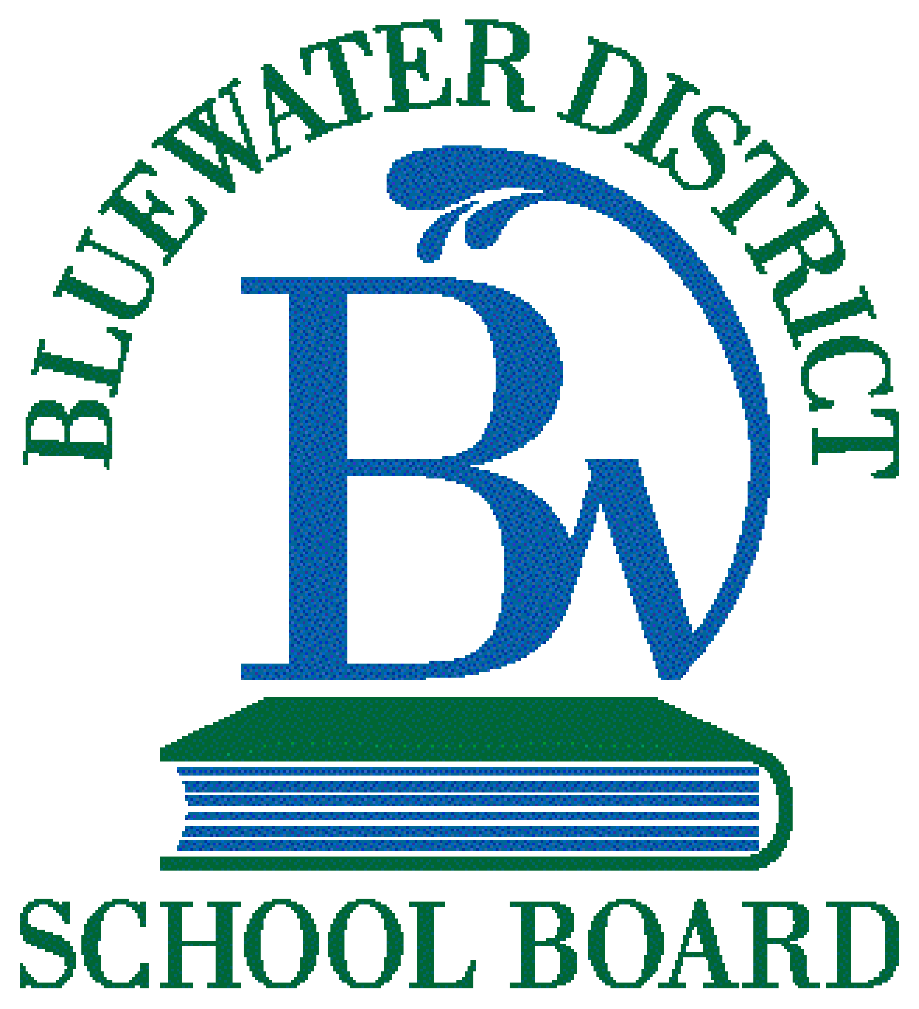
Bullying Prevention and Intervention School Plan – Normanby Community School

Bluewater District School Board is committed to the maintenance of work and school environment that is free from any form of bullying. This commitment includes dealing promptly and effectively with incidents of bullying to ensure the board’s mission to provide a quality education for every students in a safe, accepting and caring environment.

Bullying means aggressive and typically repeated behaviour by a student where,
- the behaviour is intended by the student to have the effect of, or the student ought to know that the behaviour would likely to have the effect of:
i. causing harm, fear or distress to another individual, including physical, psychological, social or academic harm, harm to the individual’s reputation or harm to the individual’s property, or
ii. creating a negative environment at a school for another individual.
- the behaviour (including the use of any physical, verbal, electronic, written or other means) occurs in a context where there is a real or perceived power imbalance between the student and the individual based on factors such as size, strength, age, intelligence, peer group power, economic status, social status, religion, ethnic origin, sexual orientation, family circumstances, gender, gender identity, gender express, race, disability or the receipt of special education.

Bullying has the potential to:
- negatively affect students’ learning, attendance, safety/sense of safety, sense of self-worth and overall mental health and well-being; and
- create a negative environment at school or school-related activities for an individual, group or the whole school

Cyber-bullying is the act of engaging in bullying behaviours through electronic means such as social media platforms, email, text or direct messaging, digital gaming and/or communication applications. Examples of cyber-bullying may include, but are not limited to:
- sending or sharing hateful, insulting, offensive, and/or intimidating electronic communication or images via text messages, emails, direct messages;
- revealing information considered to be personal, private, and sensitive without consent;
- making and/or engaging, and/or participating in fake accounts on social networking sites to impersonate, humiliate and/or exclude others; and
- excluding or disrupting access to, a student on purpose from online chat groups, access to accounts and during digital gaming sessions.

Reporting of Bullying Incidents – please refer to AP 6821-D “Bullying Prevention and Intervention”:
7.2 Reporting of Bullying Incidents by Board Staff
7.3 Reporting of Bullying Incidents by Students
7.4 Reporting of Bullying Incidents by Parents/Guardians

Safe and Accepting Schools Team  As outlined in Policy/Program Memorandum (PPM) No. 144, “Bullying Prevention and Intervention”, schools must have in place a Safe and Accepting Schools Team. This team is responsible for fostering a safe, inclusive and, accepting school climate that must be chaired by a staff member and include the principal, at least one parent, teacher, non-teaching staff member, or community partner. It should also include at least one student. | Safe and Accepting Schools Team Members – <Enter Year>
 | School: Normanby Community School
 | Chair: Mrs. Julia Lantz
 | Principal/Vice-Principal: Ms. Janice Daize
 | Teacher: Mrs. Julia Lantz
 | Non-Teaching Staff:
 | Student: Group of Grade 7/8 students
 | Parent: Denis McCarroll
 | Community Partner: West Grey Police Chief Robert Martin and Constable Chad Brown
 | Other(s):

Bullying Prevention and Intervention School Plan
The information in the each of the sections are suggested/potential ideas that school teams may wish to consider when developing their plan. Please add other ideas, and remove ideas that do not apply.
Our Goal: to continue to develop a positive, welcoming and inclusive learning environment for all students, staff, and visitors

Need(s)  (identified through data analysis)  Examples:  - school climate survey data  - suspension data  - achievement data  - ISNT referrals  - office referrals  - incident reports  - anecdotal reports | Prevention and Awareness Raising  (students, staff, parents/guardians, community)  - integrate bullying prevention, and equity and inclusion into classroom instruction (i.e., health, media, drama)  - teach, model, embed citizenship and character development in classroom instruction  - display Code of Conduct  - engage parents/guardians and community partners in school initiatives  - participate in Bullying Awareness Week and other year-round activities to promote awareness and inclusion (e.g., pink shirt day)  - promote resources for students, parents, staff  - promote a variety of clubs and groups (e.g., GSA)  - engage in professional learning opportunities (e.g., staff meetings)  - to support and continue to develop understandings of conflict vs bullying
Programs, Interventions and Other Supports  (students who are impacted, and students who are involved in bullying behaviours)  - use of progressive discipline and consideration of mitigating factors  - collaborative problem solving  - address bystander behaviour  - co-constructed class agreement focusing on inclusion  - establish follow-up plan when incidents occur  - referrals to outside agencies when relevant and available for additional supports | Communication and Outreach Strategies  (reaching students, parents/guardians, community)  - post school Bullying Prevention and Intervention Plan on school website  - share information during school assemblies as well as on daily announcements  - include information on school website, SchoolMessenger messages, and social media  - share information at school council and other parent meetings  - share information at staff meetings
Monitoring and Review
(schools will monitor, review, and evaluate the effectiveness of their Bullying Prevention and Intervention Plan with staff through school improvement planning)

NOTES:
The Bullying Prevention and Intervention Plan will be consistent with the policies and procedures of the board, and will be updated annually.

The school’s Bullying Prevention and Intervention Plan will be made available to the public through the school’s website.

